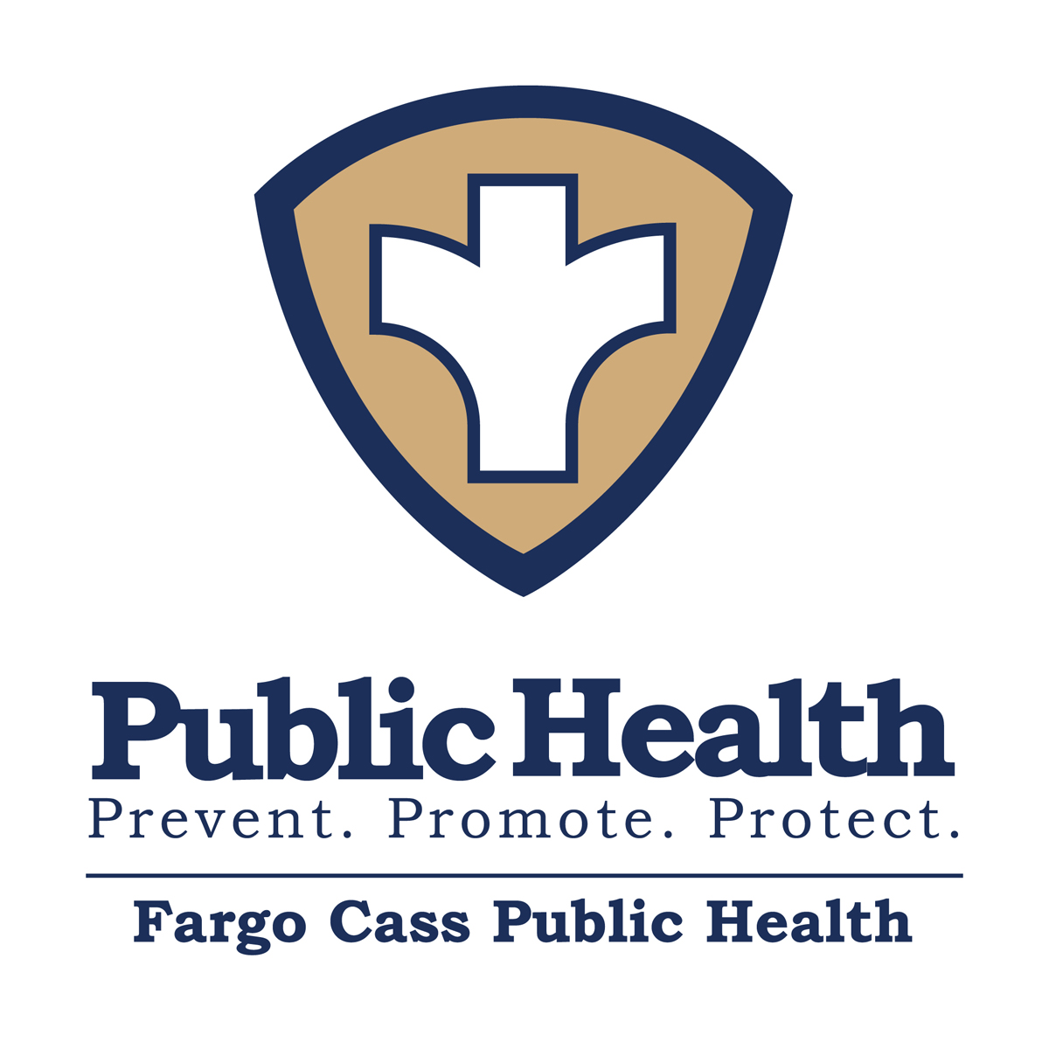

Naloxone Adminstration Training
To determine whether or not today’s Naloxone administration training met your needs and our objectives; we would like you to give us your honest opinion of the content, instructor, and value of the course. Please answer the following questions.

Content of the Training
 | Strongly Agree  5 | Agree  4 | Neither Agree nor Disagree  3 | Disagree  2 | Strongly Disagree  1
- To me, the content of the Naloxone Administration training was about right.
- The class met my needs for knowledge and information to administer naloxone in its various forms.
- This class emphasized the importance of steps to take in the event of an opioid overdose.
- This class taught me some important intervention techniques for overdose victims.
- I would recommend this training to other groups.

Instructor(s) Evaluation
 | Strongly Agree  5 | Agree  4 | Neither Agree nor Disagree  3 | Disagree  2 | Strongly Disagree  1
- The instructor was easy to follow and understand.
- The instructor presented information in a manner that allowed me to focus on the materials.
- The instructor demonstrated knowledge of Naloxone Administration.

Other Comments
- Do you have additional comments regarding the instructor and/or Naloxone Administration training?
Date: ______________

